S

]

2

mn rank(AB) ≤ min{rank(A), rank(B)}rank(AB) ≤ min{rank(A), rank(B)}

1)

a)

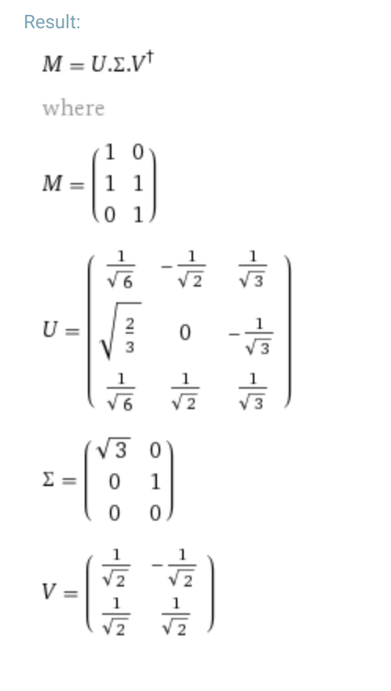

b)

i)

range(A) = span([1, 2, 3]T, [1, 1, 1]T)

null(AT) = c[1, -2, 1]T

ii)

[1, 3, 7]T = a[1, 2, 1]T + b[1, 1, 1]T

=> a + b = 1, a + b = 7 => inconsistent

-----------not sure if this is right-------------

[1, 3, 7]T = a[1, 2, 3]T + b[1, 1, 1]T

=> a = 2, a = 4 => inconsistent

----------------------------------------------------

range(A) orthogonal to null(AT),but [1,3,7] not orthogonal to [1,-2,1]

iii)

Solve ATAx = ATb, => x = [3, -7/3]T

c)

i)

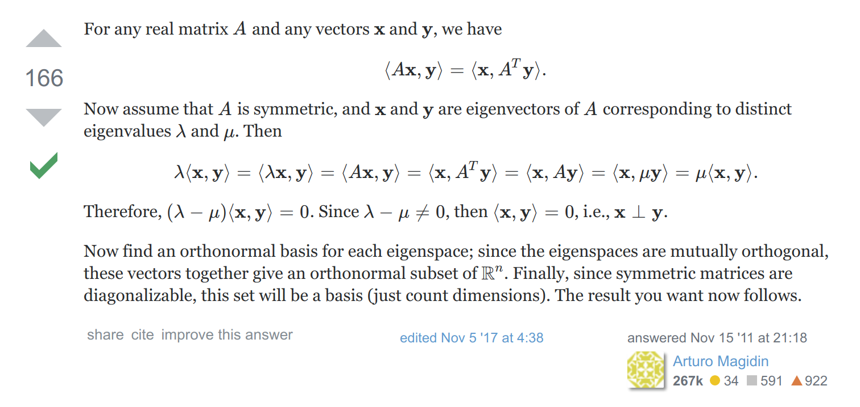

Similar proof that’s a bit clearer:

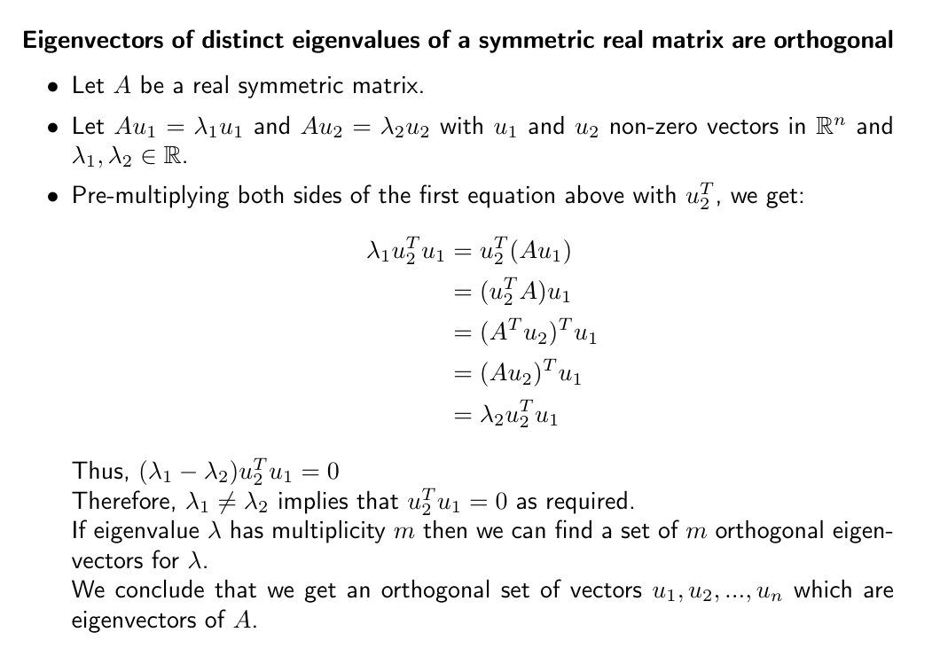

ii)

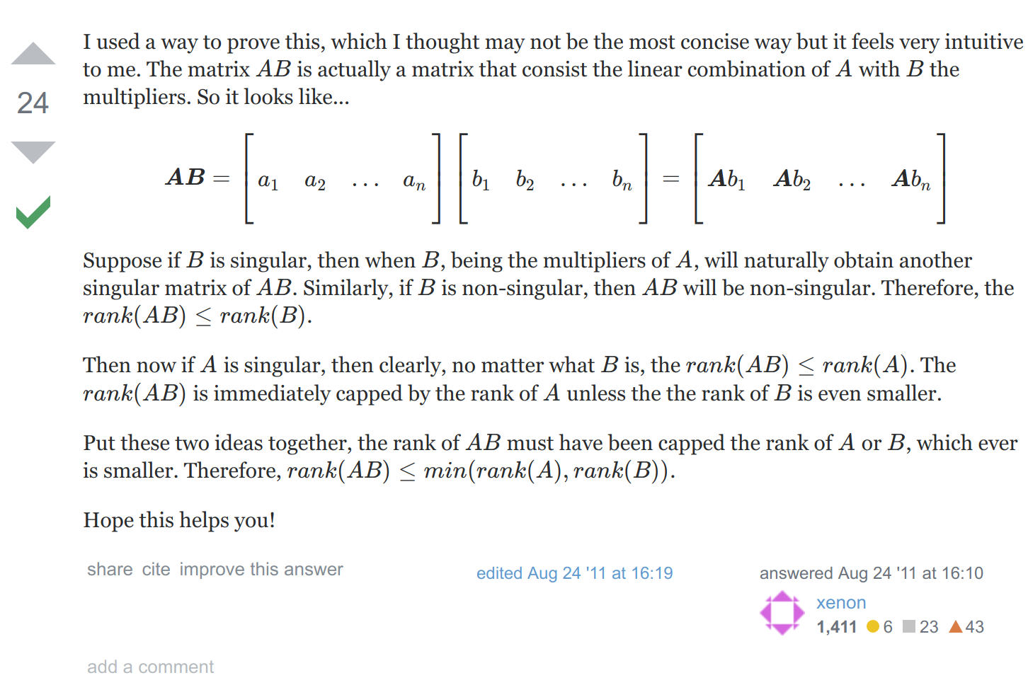

2a)

i)

7 x 50/26 = 175/13

ii)

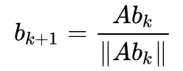

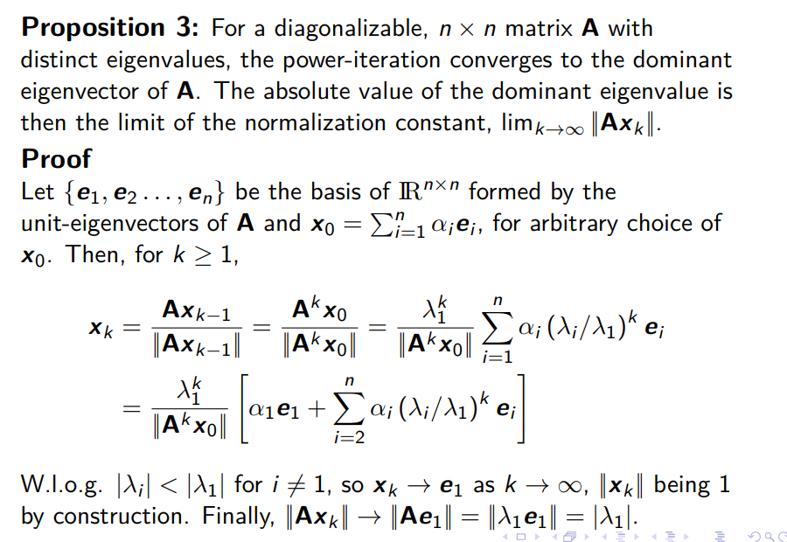

b)/

i) No stationary points.

ii) Saddle at (0,0).

iii) Minimum at (1/12, -1/6), saddle at (0, 0)

c)

i)

Laplace transform of 1 is 1/s.

ii)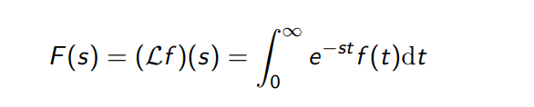

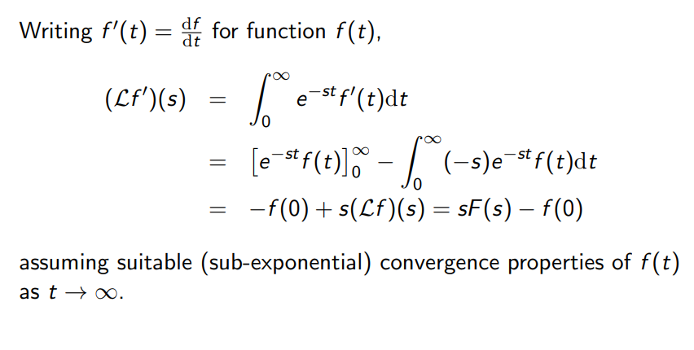

iii)

